Raspberry PI Wireless Headless Configuration Guide

1. Remove all USB sticks from computer!
2. Insert microSD card in card reader, if prompted for Format, not necessary. Take note of the letter which appears. Might be two different drives.





1. Launch Win32DiskImager.

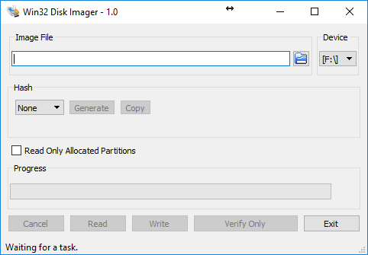

1. Extract from WinZip Raspberry PI archive. Lite is without GUI and faster.



1. Select the img file to be written, target device in Win32 Disk Imager, then press Write.

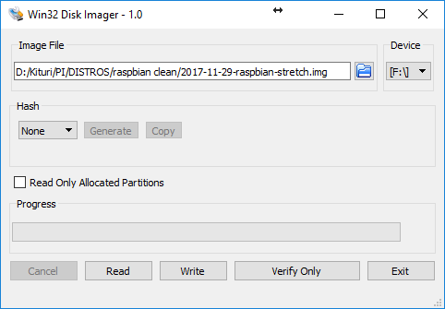

1. Check again that you have correct device letter selected (usually the one with boot is the correct one).

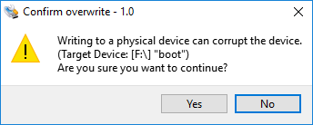

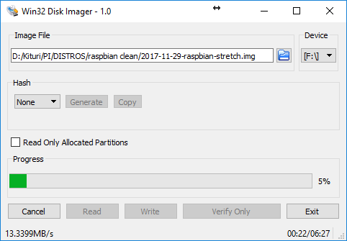

1. Wait until the job is finished. If an error message appears, remove the microSD card from reader and format it again.

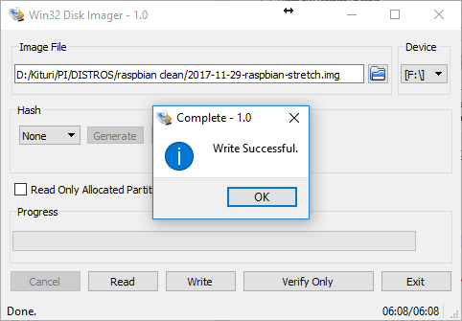

1. Edit the file wpa_supplicant.conf with your wi-fi settings.

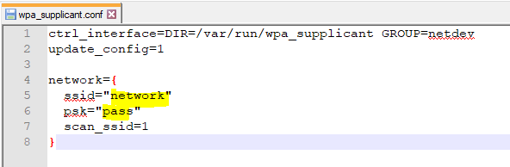

1. Copy to boot the two files wpa_supplicant.conf and ssh.

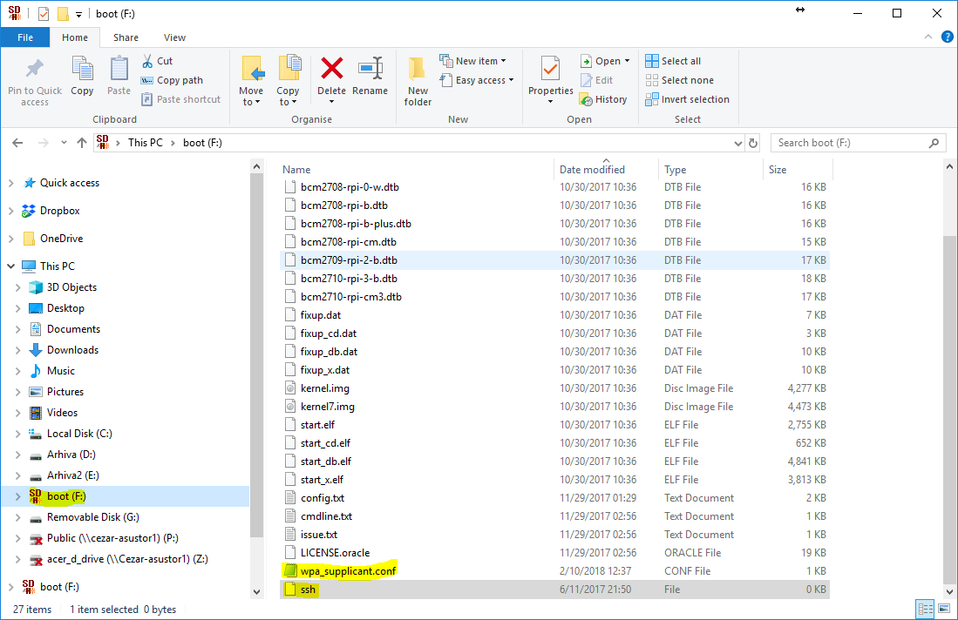

1. Remove SD card from laptop. Insert microSD card in Raspberry PI.
2. Switch on hot-spot on smartphone if using smartphone hotspot, otherwise make sure wifi network is connected.
3. Connect laptop to smartphone hotspot or wifi network.
4. Connect Raspberry PI to power.
5. Open cmd, launch ipconfig /all.

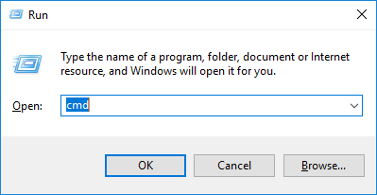

1. Take note of the IP address assigned by the smartphone.

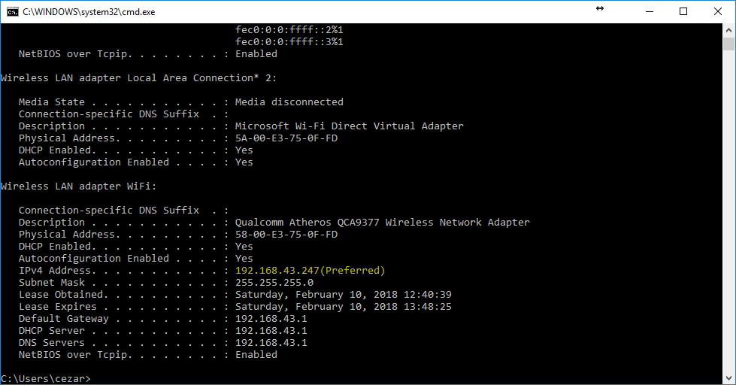

1. Open IPScan application. Search for devices in the same network as it was assigned by the smartphone, i.e. if you have 192.168.43.247 assigned search for /24 network addresses 192.168.43.0 – 192.168.43.255.

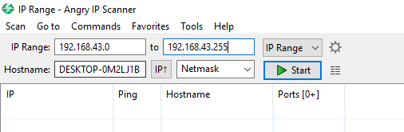

1. Sort the result by ping to obtain the list of computers. The raspberrypi computer should appear.

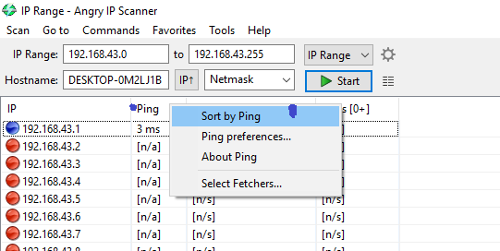

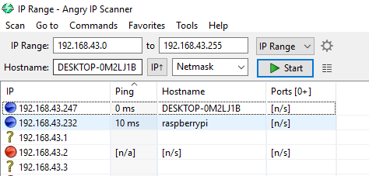

1. Open Git Bash on computer.



1. Write ssh [pi@192.168.43.232](mailto:pi@192.168.43.232) where the IP is changed to what you have on the IP scan results. Confirm with yes, then put password raspberry.

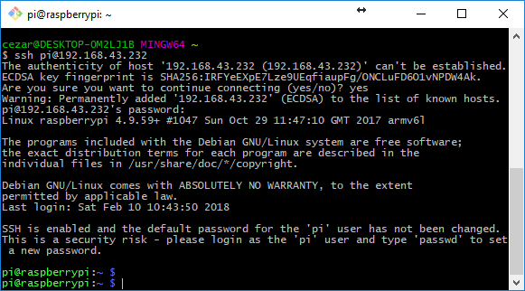

1. If you get a warning message then you should delete the known hosts by the command rm ~/.ssh/known_hosts

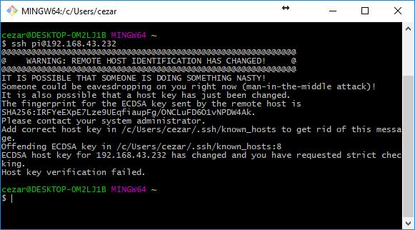

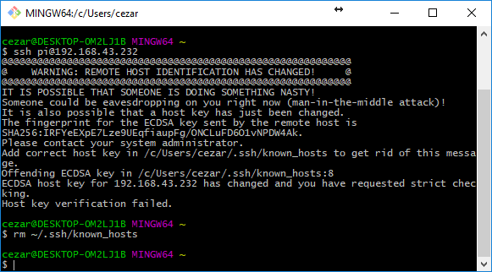

1. If you are on home WiFi router: Run command sudo apt-get update

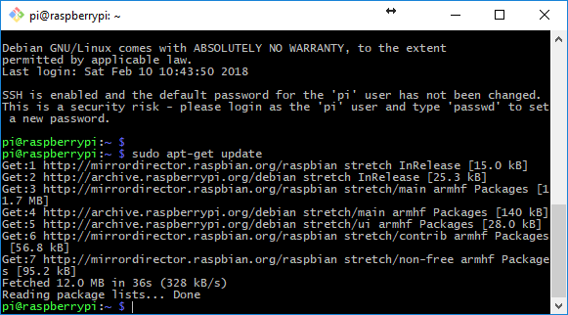

1. If you are on home WiFi router: Run command sudo apt-get upgrade.
2. If you have installed the graphical version of Raspbian and you want to connect from VNC, run the following command sudo apt-get install realvnc-vnc-server realvnc-vnc-viewer

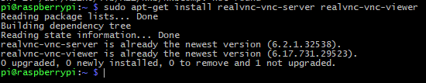

1. Run the command vncserver.

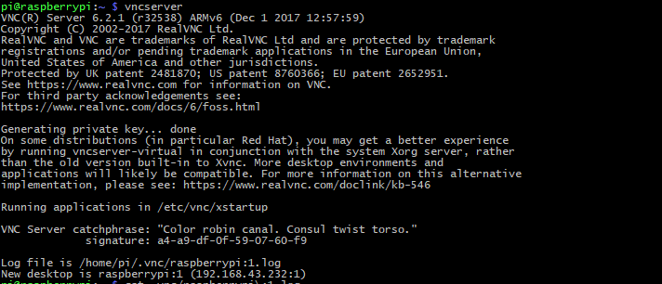

1. Launch the realvnc viewer program and type the address of the raspberry pi.

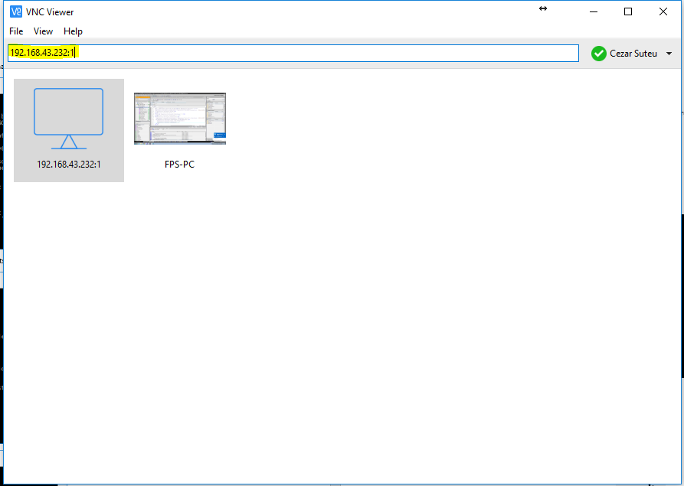

1. Username is pi. Password is raspberry.

